GitHub
Conteúdo

Cmake 2
Download 2
Install 2
Livro: Mastering CMake 3.1 Edition 2

GitHub - desktop

vcpkg is a cross-platform command-line package manager for C and C++ libraries. It simplifies the acquisition and installation of third-party libraries on Windows, Linux, and macOS. If your project uses third-party libraries, we recommend that you use vcpkg to install them. vcpkg supports both open-source and proprietary libraries. All libraries in the vcpkg Windows catalog have been tested for compatibility with Visual Studio 2015, Visual Studio 2017, and Visual Studio 2019. Between the Windows and Linux/macOS catalogs, vcpkg now supports thousands of libraries. The C++ community adds more libraries to both catalogs on an ongoing basis.

Download
The latest release should be downloaded from: https://desktop.github.com/

Installing on Windows
The first time the installation program is executed, the program will ask for your GitHub account. In case you do not have a GitHub account, it may be created before.

Hit the Sign in to GitHub.com button.



On the next step, the GitHub will open a browser to validate the desktop where the program is being installed, follow the instruction and after the validation the following screen will be presented:

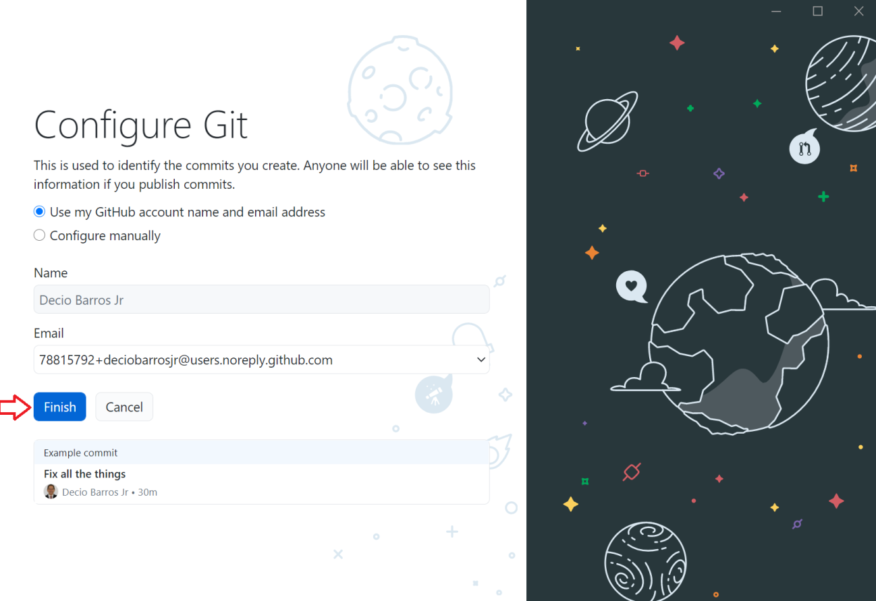

Hit the Finish button to complete the installation.
On the next screen, you may choose the desired option or just Exit to finish the installation process.

File -> Exit

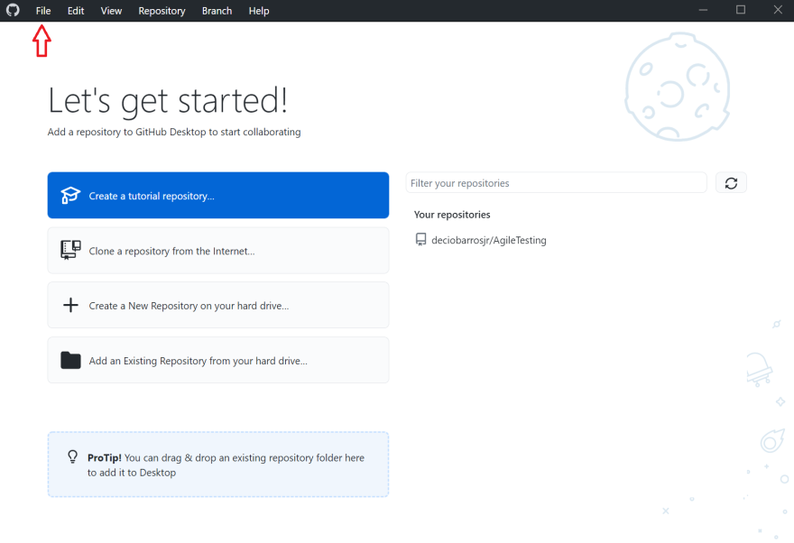

GitHub windows will be installed on your user folder, example:

C:\Users\decio\AppData\Local\GitHubDesktop\bin\GitHubDesktop.exe

The following PATH will be automatically added to your PATH env variable:

C:\Users\decio\AppData\Local\GitHubDesktop\

